CSE 230 Problem Set 13

# Problem 29.1: Currency

Consider the following problem definition:

A class is designed to represent currency (money). In this case, the currency is always positive and the smallest denominations are cents. This class is used in a financial application that has direct user textual input.

Please do the following

1. Create a class diagram to describe the class:

|  |
| --- |
| Currency |
| -int cents |
| +Currency()  +Currency(input : double)  +set(input : double)  +add(input : double)  +subtract(input : double)  +get() : double  -convertToCents(input : double) : int |

1. Create a DFD to illustrate how data moves into and out of the member variables. Hint: you might want to draw this out and insert a picture.

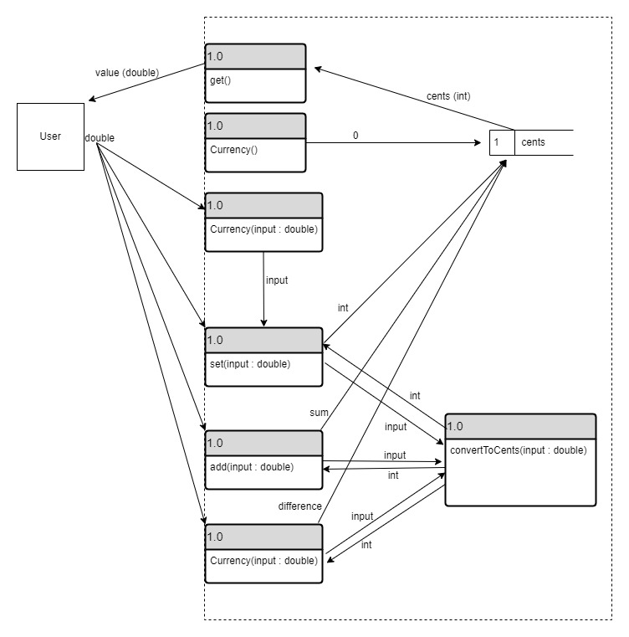

1. Provide pseudocode for the methods responsible for keeping the member variables in a valid state.

Currency()

sents 🡨 0

Currency(input : double)

set(double)

set(input : double)

IF double < 0

Cents 🡨 0

ELSE

Cents 🡨 convertToCents(input)

convertToCents(input : double)

RETURN (int)(input * 100)

add(input : double)

input 🡨 convertToCents(input)

cents 🡨 cents + input

subtract(input : double)

input 🡨 convertToCents(input)

IF cents > input

cents 🡨 cents – input

ELSE

cents 🡨 0

get() const

returnValue 🡨 (double)(cents) / 100

RETURN returnValue

# Problem 29.2: Spaceship Fuel

Consider the following problem definition:

A class is designed to represent the fuel amount in a spaceship. A variety of interfaces can adjust the fuel level, including refueling stations, bonus fuel loads, and the engines that consume fuel the more they are used.

Please do the following

1. Create a class diagram to describe the class:

|  |
| --- |
| Spaceship_Fuel |
| -double fuel_level  -double max_fuel_level |
| +Spaceship_Fuel()  +Spaceship_Fuel(double amount,double max_amount)  +add_fuel(double amount)  +spend_fuel(double amount)  +get_fuel_level() : double  +get_max_fuel_level() : double  -set_fuel_level(double amount)  -set_max_fuel_level(double amount) |

1. Create a DFD to illustrate how data moves into and out of the member variables. Hint: you might want to draw this out and insert a picture.

1. Provide pseudocode for the methods responsible for keeping the member variables in a valid state.

Spaceship_Fuel()

set_fuel_level(0.0)

set_max_fuel_level(10.0)

Spaceship_Fuel(amount: double, max_amount: double)

IF max_amount <= 0

RETURN Spacehip_Fuel()

ELSE

set_max_fuel_level(max_amount)

set_fuel_level(amount)

get_fuel_level() const

RETURN fuel_level

get_max_fuel_level() const

RETURN max_fuel_level

set_max_fuel_level(amount: double)

IF max_amount <= 0

RETURN error

ELSE

max_fuel_level = amount

set_fuel_level(amount: double)

IF amount < 0

RETURN error

IF amount > get_max_fuel_level()

fuel_level = get_max_fuel_level()

ELSE

fuel_level = amount

add_fuel(amount: double)

IF amount <= 0

RETURN error

IF amount + get_fuel_level() >= get_max_fuel_level()

set_fuel_level(get_max_fuel_level())

ELSE

set_fuel_level(get_fuel_level() + amount)

spend_fuel(amount: double)

IF amount <= 0

RETURN error

IF get_fuel_level() - amount < 0

RETURN error

ELSE

set_fuel_level(get_fuel_level() - amount)